

**Natyral ATC Requirements Specification**

**June … , 2022**

***1. Executive Summary***

*1.1 Project Overview*

NATYRAL & ATC was founded in 1992, located in Durrës, Albania. Its main activity is the collection, processing, production and trade of herbs, spices, tea, essential oils and super-foods. They collect the local herbs and spices from local gatherers and import the exotic spices from the international market. Their products are in the shelves on markets and supermarkets in Albania, United States, United Kingdom, Kosovo, United Arab Emirates etc. They also export local herbs in the United States, Italy, Hungary, Bulgaria, UAE, Kosovo, Japan etc.

*1.2 Purpose and scope of this Specification*

***2. Product Service/Description***

The software that we are going to create aims to help the company to make a better organization of the work that is needed to be done, track the progress and also keep the owners updated with the latest issues according to production, delivery, finance etc. This software is build to meet the needs of the company. We think that this product will be independent from other software-s that the company is currently using, it will have different features and goals but the communication between it and other useful software-s will be available.

Building an effective software might help the company to:

* drive down cost,
* minimize necessary manpower,
* reduce time for certain operations,
* increase the total output,
* increase the company’s efficiency.

This software will be trying to basically satisfy the needs and the requests of the owners, managers and different department headers.

*2.1 Product Context*

The software will be called “AYN”, which stands for “all you need”. This solution is in aid of Natyral ATC sh.p.k and aspires to provide as much efficiency as possible in order to make the company processes more controllable and less time-consuming. This solution is going to be used by the company CEO but not forgetting head managers and limited access will be provided for department headers to.

*2.2 User Characteristics*

AYN combines the interaction of three main types of users:

* administrator (in this case will be the CEO of the company, Mr. O.L)
* head managers
* department headers

**Administrator (super-admin):**

The administrators are the CEO-s of Natyral ATC, Mr. O.L and his wife Mrs. L.L. They are the persons that are in charge of everything and where all the information is reported in the end of the day. This means that they are the ones controlling all the processes and making sure that the company’s progress is going well, so this means that they are going to have unlimited access in the software.

The tasks that each of them can do are the followings:

1. create/delete profiles of employees,

2. checking the payments of each employee,

3. update the location of the company,

4. see/control all the deliveries,

5. check the daily inventory system,

6. control and update the employee chat system,

7. control all the financial records (daily/monthly/yearly),

8. check the security cameras of all environments of the company,

9. give permission to department headers requests for sick leave.

**Head Managers (admin-s):**

Just like in every company, head managers play a major role in controlling and maintaining the efficiency of the company. These positions include: head manager of transport, head manager of packing, transaction & finance manager, head manager of raw materials cleaning process and head manager of security. All these managers perform tasks that help the CEO-s to keep track of the company progress. They will have a more limited access in the AYN, each one of them in their specific part.

**Department Headers:**

In this section are included those people in the first line of production, who must report the daily production in the respective managers. A department header is “the leader” of workers in a specific department, he is the one worker who has the closest connection with managers and a little with owners.

The tasks that each department header can do in the system are:

1. fulfill the daily reports of production,

2. check the monthly quantities of products generated,

3. check the deadline by which the product must be finished,

4. register his workers and their work-hours,

5. asks for permission to take sick leave for himself & other workers under his command.

*2.3 Assumptions*

About AYN:

* The CEO-s of the company will have unlimited access to all types of data entered by the managers and department headers.
* The sick leave requests will be protected and private.
* The devices in which this software will be running must have Linux/IOS/Windows operating systems.
* It is supposed that the users of this software must have a valid internet connection.
* Every important notification done by the CEO-s and managers will be available for every other user (inside the company).

*2.4 Constraints*

About this software:

* Every user must have some basic computer knowledge.
* The software should be used within the working hours, or extremely 15 minutes after the shift. (but the user must be inside the company environments)
* Every user must be logged in before using the software, in order to avoid misunderstandings.

*2.5 Dependencies*

* Only CEO-s will have unlimited access into personal data of the employees.
* If CEO-s are not available, managers must ask for access in order to get personal information about employees.
* The department head have the right to register only 1 time the daily product on the system (after clicking finish they cannot change the inserted information).
* CEO-s have the rights to observe the production in all departments while head managers have the right to access the production in their own sector.

***3. Requirements***

*3.1 Functional Requirements*

|  |  |  |  |  |  |
| --- | --- | --- | --- | --- | --- |
| Req# | Requirement | Comments | Priority | Date Rvwd | SME reviewed/approved |
| BR_01 | The software should support inventory management system. | This helps on better organization of work. | 1 |  |  |
| BR_02 | The software should support employee payroll system. | Make it easier to identify/change wages. | 1 |  |  |
| BR_03 | The software should be able to assist in the preparing and maintenance of company financial records. | When financial reports needed, they can be easily found. | 1 |  |  |
| BR_04 | The software should include a special part for the location of the company. | For new employees/customers more easy to find. | 2 |  |  |
| BR_05 | Products should be available in the software. | To attract more customers by showing the variety. | 2 |  |  |
| BR_06 | A delivery management system should be supported by the software. | An extra feature of the company to attract audience. | 1 |  |  |
| BR_07 | The software may provide an employee chat system (only for important announcements). | Not everyone might check the whatsapp or other social media. | 1 |  |  |
| BR_08 | The super-admin must be able to create/delete the employees profiles. | Since the data of employees must remain private. | 1 |  |  |
| BR_09 | The super-admin and also the transaction manager should be able to check the all employee wages. This data will be best to be represented in tabular form. | More organization | 1 |  |  |
| BR_10 | The administrator and the transport manager should be provided with all delivery data represented in tabular form. They both can add/delete/edit transport records, but also schedule future events. Data is displayed in tables. | To keep track of all deliveries and the dates also. | 1 |  |  |
| BR_11 | Only the super-admin must have access in the employee chat system. | Not to create confusion and to keep clear the function of the chat. | 1 |  |  |
| BR_12 | Super-admin and the finance manager must have access in the financial records of the company. They can add/delete and also edit financial records related with the business. All the data will be represented in tabular form, also provided pie charts and column diagrams. | In order not to create confusion on mass. | 1 |  |  |
| BR_13 | The super-admin and the head of security department can have unlimited access in security cameras, but first they must be logged in by entering a password and a fingerprint. The security officers have limited access only in the working hours and the only operation allowed to be performed by them is camera-checking. Super-admin and head of security department can turn on/off the cameras, check the previous registrations, turn on/off the alarm system etc. | In order not to create confusion on mass. | 1 |  |  |
| BR_14 | The super-admin can give permission to workers to leave, by clicking the button “approved” when receives the notification by the department head. In the notification will be specified the hour, name/surname of the employee, what is his duty, the reason why asks to leave and the department header name/surname. The notification will have 2 options “Accepted” “Denied”. | This will be less time consuming than face-to-face method. | 2 |  |  |
| BR_15 | The department headers will be provided with their own section when they can upload the daily production. This process will consist of fulfilling a form with basic information required (date, starting hour, ending hour, employee names, name of products, quantity, amount of work done by each employee, DH name). After fulfilling it the DH must press the button “Submit”. If the paper is submitted correctly, a message “Success, the form is sent ☺!” will be displayed on the screen. | This minimizes the opportunities that the daily production papers will be lost due to carelessness of different peoples included in the process. | 1 |  |  |
| BR_16 | The DH can check the monthly quantities of products generated. This data will be presented in tabular form. | This allows him to calculate the work left to be done and also not to waste time. | 1 |  |  |
| BR_17 | The DH can check the deadline by which the product must be finished. When the deadline will be in 3-4 days, the system can display a warning message like “Warning! The (product name) deadline is due (date)!!” | Sometimes the transportation and production have misunderstandings. | 1 |  |  |
| BR_18 | The DH can register his workers and their working-hours. This data will be registered in tabular form. | This is done in order to keep track of the working hours (appx 40h/w) and also to have a fair competition for the “employee of the month”. | 2 |  |  |
| BR_19 | The DH can ask for permission to take sick leave for himself & other workers under his command. In order to do it he must fill a form with basic information like: the hour, name/surname of the employee, what is his duty, the reason why asks to leave and the department header name/surname. After he must press the button “Ask for permission”. | This will be less time consuming than face-to-face method. | 2 |  |  |

*3.2 Non-Functional Requirements*

**3.2.1 Product Requirements**

*3.2.1.1 User Interface Requirements*

* AYN will be an application available for pc & laptop with WINDOWS/LINUX operating system and also for mobile phone, android/IOS.
* The system is thought to be simple and communicative, so it won’t be necessary for the user to read the guideline. In order to achieve this, the system will not have any complicate interfaces for any of its users.
* The main page will be informative page about the business and also will display different pictures on the background. At the top is thought to have a main menu in which the user can select the profile he wants to be identified during the usage of the app (administrator, DH, manager, etc) and after selecting a simple log in page will be shown requiring the email/username and also the password. At the end of the page will be shown the contact information (a phone number, company’s instagram, facebook and gmail).
* The administrator page (super-admin page) will be organized in different sectors for each of company’s processes including: production, finance, transport, security, chat etc. It is thought that when the administrator will be logged in, all the sites where he has access will be displayed in the middle of the screen separated in squares, so not to create any confusion. The same thing will be with the managers page.

*3.2.1.2 Usability*

**3.2.1.2.1****Accessibility:**

As mentioned before, AYN will be an application and it can be accessed only if the user has internet connection and also is inside the business environments.

**3.2.1.2.2 Responsiveness:**

The application is thought to be extremely responsive and fast too.

**3.2.1.2.3****Flexibility:**

The application is thought to adapt the updates very easy but also deal with errors/problems as quick as possible.

**3.2.1.2.4****Effectiveness:**

* This application will be easy to use and understand and as user-friendly as possible.
* To minimize the chances of failing in understanding AYN, in the app will be included a section called “About Me”, in which each user can find all the procedures needed to be done in order for him to use the application.
* In case the user deals with an error, the messages will be easy to understand and also associated with a step-by-step procedure in order to get rid of it.

**3.2.1.2.5****Efficiency:**

* The application is going to be very efficient and 0 time-consuming, meaning that each user will fulfill his tasks super fast and in the best case with no errors/warnings at all.
* The interface will also be very easy and user-friendly with no complicated buttons or actions.

*3.2.1.3 Efficiency*

**3.2.1.3.1 Performance Requirements**

* Since AYN is going to be installed in a computer/laptop/mobile, the data will be delivered in real-time, and it will only be accessible inside company’s environment it will require good internet connection, and new tech devices in order to reach its best performance, but also with mid-range devices it will work just fine.
* The bigger the space, the more will be the users therefore the better the performance.

**3.2.1.3.1 Space Requirements**

* The app will be able to handle at least 100 users at a time, and the database system should handle at least 300-400 users at any given time.
* Maximum user load: 100.
* Per-user memory requirement: 2-4 GB RAM.

*3.2.1.4 Dependability*

**3.2.1.4 .1Availability:**

* The application will be available only during the working hours, but for specific users it will be available 24/7.
* The app will be accessed only inside the business environments.
* Internet access is necessary.

**3.2.1.4 .2Monitoring:**

**3.2.1.4 .3Maintanence:**

* The app will be updated when necessary in order to process all the operations in real time.
* In case the system will crash, the app should not display anything to the user except an error message “The system isn’t available right now! See you soon!”
* If the crash happens the system should start as soon as possible.

**3.2.1.4 .4Integrity:**

* The personal information must be available only for the super-admin.
* The super-admin account is the only one responsible for adding/deleting new employee accounts.
* All users should provide personal credentials to log in into the system and should be authenticated before accessing their own profiles.

*3.2.1.5 Security*

* When the super-admin creates a new profile, an informative email must be sent to the employee to let him know about the action.
* When a new user is logged in, a randomly generated password must be sent to it by the super-admin email.

**3.2.1 Domain Requirements**

AYN is going to be an application that can be easily downloadable from both AppStore and PlayStore, and is going to be an organizational app exclusively for the “Natyral Atc” company. The main purpose of this app is the digitalization of the company’s data and careful handling of the production information. The application is thought to be divided in 2 parts for use, one use will be from the company workers (CEO, managers, employees) and the other one will be for clients but with a limited actions (like viewing products and making orders-specifically big orders). The app will be mostly employee-use oriented. In order to access the functionalities of the app the user must firstly be logged in with the email that they have been registered to the company and the whole data will be manipulated into company’s servers. A must for using the application will be location of the user (inside company’s environments) and stable internet connection.

***4. Software Designs***

**4.1 User Scenarios**

*1. Successful log in:*

1. The user will manually fill the email input box.

2. The user will manually fill the password input box.

3. The app will check inputs with database records, if they match the user is successfully logged in.

4. In the users screen will be displayed the home page of his/her own page.

*2. Failing to log in*

1. The user will manually fill the email input box.

2. The user will manually fill the password input box.

3. The app checks the input with the database records, inputs doesn’t match.

4. A message will be displayed to user, asking to enter the wrong input again.

5. User remains at the log in page.

**Administrator Scenarios:**

*1. Creating the employee account*

1. The administrator is firstly logged in.

2. He/She clicks on “Employee Accounts” section, on a left column in the screen where are listed all sections.

3. After page is opened it selects the option “Create” from 3 options, “Create”, “Delete”, “Update”.

4. The administrator starts filling the field with information about the new employee.

5. After adding all the information, he clicks the button “Confirm”.

6. A message “Are you sure you have entered the correct information” will be shown in the screen.

7. Administrator clicks “Yes” and the account is successfully created.

*2. Deleting the employee account*

1. The administrator is firstly logged in.

2. He/She clicks on “Employee Accounts” section, on a left column in the screen where are listed all sections.

3. He/she searches for the name of the employee at the search bar.

4. When found, the administrator clicks on the button “Delete”.

5. A confirmation table will be shown in the middle of the screen with message “Are you sure you want to delete it?”

6. After confirmation, the account will be deleted but not permanently (it will basically be sent into a bin).

*3. Controlling employees payments*

1. The administrator is firstly logged in.

2. He/She clicks on “Employee Accounts” section, on a left column in the screen where are listed all sections.

3. He/she searches for the name of the employee at the search bar.

4. Inside the account is the “Monthly payment” field.

*4. Update the company location*

1. The administrator is firstly logged in.

2. He goes to the section “Map”, on a left column in the screen containing all sections.

3. Clicks at the button “Update Location”

4. 4 fields to fulfill appear on the screen (Country, City, Road, Details/Specifications).

5. After adding the administrator clicks button “Update”.

6. A confirmation message pops up.

7. Administrator clicks “Yes” and the location is updated.

*5. Controlling the deliveries*

1. The administrator is firstly logged in.

2. He goes to section “Deliveries” on a left column in the screen containing all sections.

3. A table with all the necessary information is shown with all deliveries listed according to date by default.

4. Administrator clicks on the button “Order” to order the deliveries by 3 different categories (name of client, date, quantity).

5. Administrator clicks on the search icon at the top of the page.

6. Administrator types the name of client and clicks enter.

7. The required delivery will be shown on the screen.

*6. Checking the daily inventory system*

1. The administrator is firstly logged in.

2. He goes to section “Inventory” on a left column in the screen containing all sections.

3. By default on the screen will be shown the latest inventory registered.

4. Administrator can check different inventories by searching for the date of inventory in the front of the page at search bar.

*7. Update the employee chat system*

1. The administrator is firstly logged in.

2. He goes to section “Chat” on a left column in the screen containing all sections.

3. He types the message that want to sent to the employees and press “Sent”.

*8. Control financial records*

1. The administrator is firstly logged in.

2. He goes to section “Finance” on a left column in the screen containing all sections.

3. Another page organized in square will be shown where each square represents one financial record like: Sales revenue, Service Revenue, Unpaid Revenue, Miscellaneous expense, Accounts receivable, Income Summary, Retained Earnings etc.

4. The administrator click to one of the squares and the table containing information for that specific record will be shown on the screen.

*9. Checking the security cameras*

1. The administrator is firstly logged in.

2. He goes to section “Security” on a left column in the screen containing all sections.

3. Another page organized in square will be shown where each square represents one environment of the company like: CEO office, Production line 1, Production line 2, Yard, Warehouse, Manager’s Office etc.

4. The administrator click to one of the squares and the current cameras recording will be shown on the screen.

*10. Permissions for sick leaves (this operation can be done through the phone)*

*10.1 Request accepted*

1. A notification will be sent to the administrator’s phone.

2. The administrator logs in.

3. He goes to section “Requests” on a left column in the screen containing all sections.

4. He reads the request sent from the department header.

5. He accepts the request by clicking “Confirm”.

*10.2 Request denied*

1. A notification will be sent to the administrator’s phone.

2. The administrator logs in.

3. He goes to section “Requests” on a left column in the screen containing all sections.

4. He reads the request sent from the department header.

5. He denies the request by clicking “Deny”.

6. An input box will be shown in the screen with description “Reason”.

7. Administrator fills the box with a brief explanation why the request was denied and press “Sent”.

8. The message is sent to the department head.

**Head Managers (admin-s) scenarios:**

*Transport Manager:*

1. He is logged in.

2. The home page will be shown with all the sections that are thought for him.

3. He goes to section “Deliveries” on a left column in the screen containing all sections.

3. A table with all the necessary information is shown with all deliveries listed according to date by default.

4. Administrator clicks on the button “Order” to order the deliveries by 3 different categories (name of client, date, quantity).

6. Administrator types the name of client and clicks enter.

*Packing Manager:*

1. He is logged in.

2. The home page divided in 3 sections will be shown on screen (Waiting, Done, To Be Done Soon).

3. When clicking on each of the options a table will be shown, with all the records for the products packaging.

4. When a product is fully packed the manager can press the “Done” button at the end of the row and the product will automatically move from “Waiting” page to “Done” page.

*Transaction & Finance Manager:*

1. He is logged in.

2. A page organized in square will be shown where each square represents one financial record like: Sales revenue, Service Revenue, Unpaid Revenue, Miscellaneous expense, Accounts receivable, Income Summary, Retained Earnings etc.

3. The manager click to one of the squares and the table containing information for that specific record will be shown on the screen.

*Security Manager:*

1. He is logged in.

2. A page organized in square will be shown where each square represents one environment of the company like: CEO office, Production line 1, Production line 2, Yard, Warehouse, Manager’s Office etc.

3. The manager click to one of the squares and the current cameras recording will be shown on the screen.

4. He can set on/off alarms by clicking a button in the top right of the screen.

**Department Header Scenarios:**

*1. Fulfilling daily reports of production:*

1. The department header is firstly logged in.

2. In front of him will be shown a button “Fill a daily report” by default.

3. When clicked it will open a form with necessary fields to fill (Date, name, surname, product, quantity, employees included, working hours etc).

4. After filling the user will press “Send”.

5. A confirmation table will be shown up.

6. After pressing “Yes” the report will be totally submitted.

*2. Check monthly quantities of products generated:*

1. The department header is firstly logged in.

2. In the left column of sections, he will click on “Product” section.

3. After clicking a table with the name of product, its code, quantity, deadline and details columns will be shown on the screen.

4. At the search bar at the top of the page checks for product by entering its name or code and then check the quantity.

*3. Check deadline of products generated:*

1. The department header is firstly logged in.

2. In the left column of sections, he will click on “Product” section.

3. After clicking a table with the name of product, its code, quantity, deadline and details columns will be shown on the screen.

4. At the search bar at the top of the page checks for product by entering its name or code and then check the deadline.

*4. Registering his workers and working hours:*

1. The department header fills the daily report.

2. Before submitting the form he marks as “Yes” the “Register employees and working hours box.

*5. Ask for permission:*

1. The department header is logged in.

2. In the left column of sections, he will click on “Permissions” section.

3. A form with different fields including: name of employee, date, day, reason for request and his name, will appear on the screen.

4. The department header press “Ask” button.

**Client Scenarios:**

1. The client opens the app

2. He goes at the bottom of the page and selects the option “Use it as a client”

3. The client home page will be shown on the screen with product pictures and advertisements displaying by default.

**4.2 Use Cases**

Use Case 1: Administrator (super-admin)

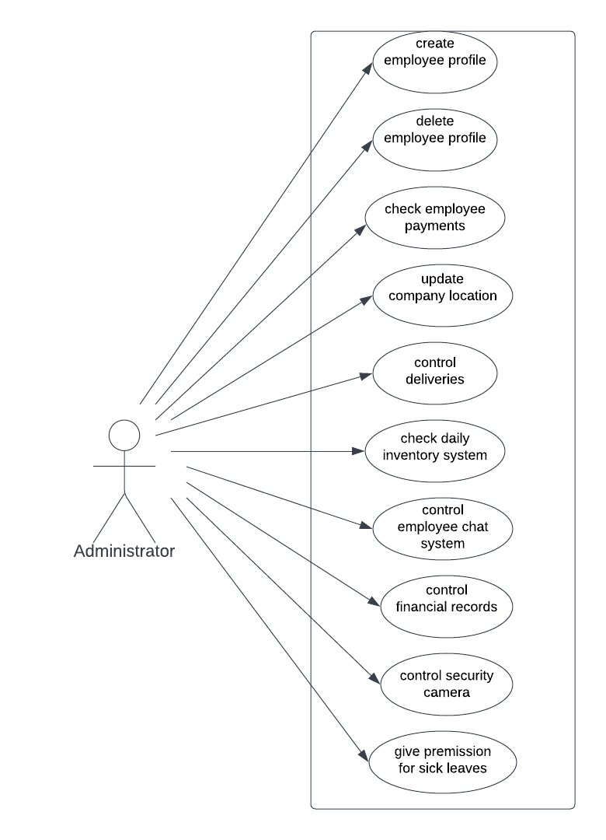

Use Case 2: Department Headers

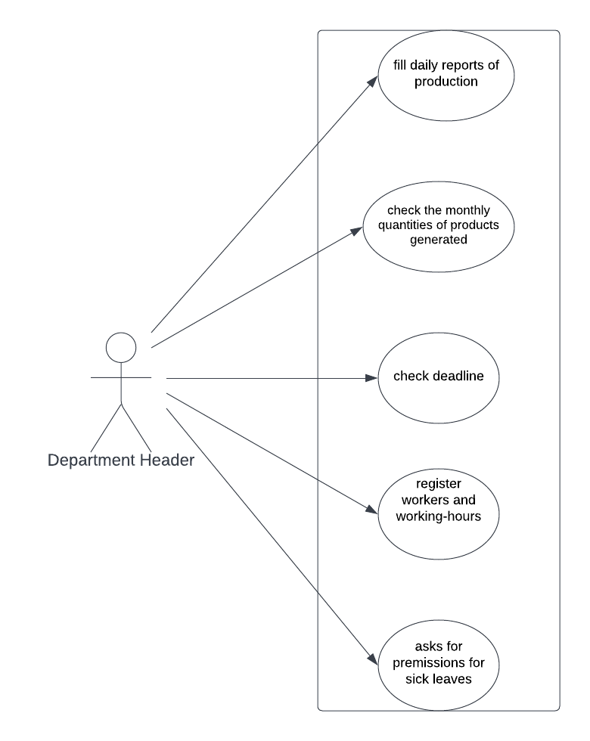

Use Case 3: Client

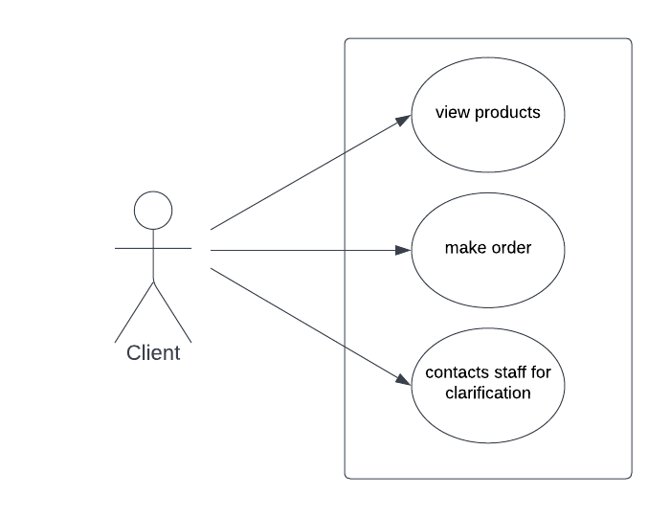

Use Case4: General Use Case

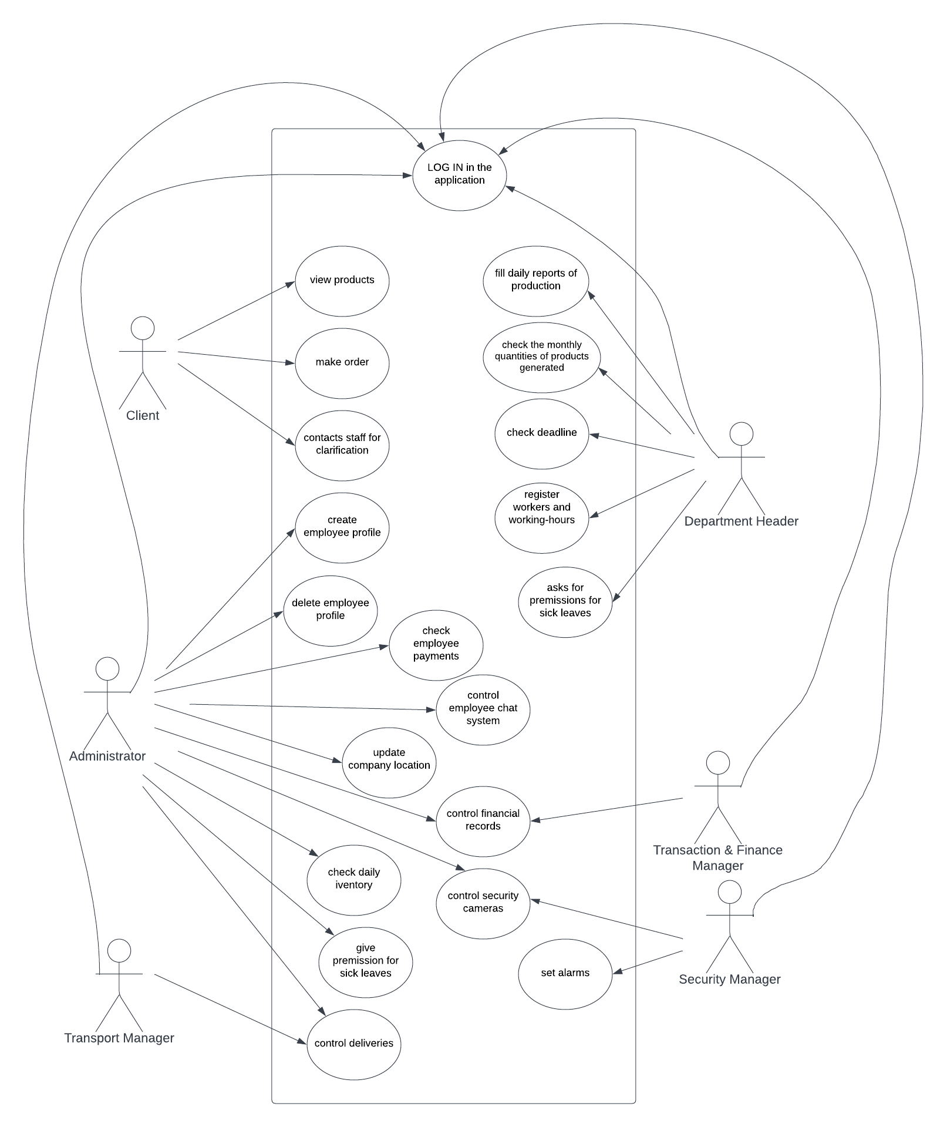

**4.3 Use Case Extended**

|  |  |
| --- | --- |
| **Use Case (UC_1.1)** | **Create Employee Profile** |
| **Scope:** | AYN application |
| **Level:** | User Level |
| **Intention Context:** | Each time a new employee comes to the company he must have an account. |
| **Minimum Guarantees:** | Account is created but not used. |
| **Success Guarantees:** | Account is successfully created, given to the employee and used by the employee. |
| **Primary Actor:** | Administrator |
| **Stakeholder’s interest:** | To simplify the work for specific actions and save time. |
| **Precondition:** | At least 1 employee. |

|  |  |
| --- | --- |
| **Use Case (UC_1.2)** | **Delete Employee Profile** |
| **Scope:** | AYN application |
| **Level:** | User Level |
| **Intention Context:** | Each time a new employee leaves the company the account must be deleted. |
| **Minimum Guarantees:** | Account is not deleted. |
| **Success Guarantees:** | Account is successfully deleted. |
| **Primary Actor:** | Administrator |
| **Stakeholder’s interest:** | To simplify the work for specific actions and save time. |
| **Precondition:** | At least 1 employee. |

|  |  |
| --- | --- |
| **Use Case (UC_1.3)** | **Check Employee Payments** |
| **Scope:** | AYN application |
| **Level:** | User Level |
| **Intention Context:** | As times as necessary check the employee payment. |
| **Minimum Guarantees:** | Administrator doesn’t check. |
| **Success Guarantees:** | When necessary he checks the payment of specific employees. |
| **Primary Actor:** | Administrator |
| **Stakeholder’s interest:** | To simplify the work for specific actions and save time. |
| **Precondition:** | At least 1employee. |

|  |  |
| --- | --- |
| **Use Case (UC_1.4)** | **Update Company Location** |
| **Scope:** | AYN application |
| **Level:** | User Level |
| **Intention Context:** | If company moves to new environments the people need to be informed. |
| **Minimum Guarantees:** | Administrator adds the new incomplete address. |
| **Success Guarantees:** | Administrator successfully adds the complete address and updates it. |
| **Primary Actor:** | Administrator |
| **Stakeholder’s interest:** | To simplify the work for specific actions and save time. |
| **Precondition:** | 1 existing location. |

|  |  |
| --- | --- |
| **Use Case (UC_1.5)** | **Control Deliveries** |
| **Scope:** | AYN application |
| **Level:** | User Level |
| **Intention Context:** | The administrator keeps track of deliveries done by his company. |
| **Minimum Guarantees:** | Administrator checks the page once in a while. |
| **Success Guarantees:** | Administrator checks the page frequently. |
| **Primary Actor:** | Administrator |
| **Stakeholder’s interest:** | To simplify the work for specific actions and save time. |
| **Precondition:** | At least 1 delivery. |
| Use Case (UC_1.6) | **Control Employee Chat System** |
| Scope: | AYN application |
| Level: | User Level |
| Intention Context: | When there are new and important news about the company that all the employees should be informed |
| Minimum Guarantees: | Administrator sends a short message to all employees. |
| Success Guarantees: | Administrator successfully informs all the employees about a specific event. |
| Primary Actor: | Administrator |
| Stakeholder’s interest: | To simplify the work for specific actions and save time. |
| Precondition: | At least 1 event/news. |

|  |  |
| --- | --- |
| **Use Case (UC_1.7)** | **Control Financial Records** |
| **Scope:** | AYN application |
| **Level:** | User Level |
| **Intention Context:** | For administrator to be informed about the financial state of the its company. |
| **Minimum Guarantees:** | Administrator checks once in a while financial records. |
| **Success Guarantees:** | Administrator checks financial records frequently. |
| **Primary Actor:** | Administrator |
| **Stakeholder’s interest:** | To simplify the work for specific actions and save time. |
| **Precondition:** | At least 1 financial record. |

|  |  |
| --- | --- |
| **Use Case (UC_1.8)** | **Control Security Cameras** |
| **Scope:** | AYN application |
| **Level:** | User Level |
| **Intention Context:** | For administrator to have a clear view of environments of the company. |
| **Minimum Guarantees:** | Administrator checks once in a while cameras. |
| **Success Guarantees:** | Administrator checks cameras records frequently. |
| **Primary Actor:** | Administrator |
| **Stakeholder’s interest:** | To simplify the work for specific actions and save time. |
| **Precondition:** | At least 1 camera. |

|  |  |
| --- | --- |
| **Use Case (UC_1.9)** | **Give permissions for sick leaves** |
| **Scope:** | AYN application |
| **Level:** | User Level |
| **Intention Context:** | In order not to waste time with meetings with many employees. |
| **Minimum Guarantees:** | Administrator just confirms/denies the request. |
| **Success Guarantees:** | Administrator gives an explanation and confirms/denies the request. |
| **Primary Actor:** | Administrator |
| **Stakeholder’s interest:** | To simplify the work for specific actions and save time. |
| **Precondition:** | At least 1 employee. |

|  |  |
| --- | --- |
| **Use Case (UC_2.1)** | **Fill daily reports for production** |
| **Scope:** | AYN application |
| **Level:** | User Level |
| **Intention Context:** | For the department header to report to the manager/administrator about the daily production. |
| **Minimum Guarantees:** | D.H reports shortly daily production. |
| **Success Guarantees:** | D.H reports a complete daily production. |
| **Primary Actor:** | Department Header |
| **Stakeholder’s interest:** | To simplify the work for specific actions and save time. |
| **Precondition:** | At least 1 employee and 1 product. |

|  |  |
| --- | --- |
| **Use Case (UC_2.2)** | **Check the monthly quantities of products generated** |
| **Scope:** | AYN application |
| **Level:** | User Level |
| **Intention Context:** | For the department header to keep track of the products and what should do next. |
| **Minimum Guarantees:** | D.H checks once in a while. |
| **Success Guarantees:** | D.H checks frequently and updates. |
| **Primary Actor:** | Department Header |
| **Stakeholder’s interest:** | To simplify the work for specific actions and save time. |
| **Precondition:** | At least 1 employee and 1 product. |

|  |  |
| --- | --- |
| **Use Case (UC_2.3)** | **Check deadline** |
| **Scope:** | AYN application |
| **Level:** | User Level |
| **Intention Context:** | For the department header to keep track of the products and how much time is left. |
| **Minimum Guarantees:** | D.H checks once in a while. |
| **Success Guarantees:** | D.H checks frequently. |
| **Primary Actor:** | Department Header |
| **Stakeholder’s interest:** | To simplify the work for specific actions and save time. |
| **Precondition:** | At least 1 employee and 1 product. |

|  |  |
| --- | --- |
| **Use Case (UC_2.4)** | **Register workers and working-hours** |
| **Scope:** | AYN application |
| **Level:** | User Level |
| **Intention Context:** | In order to keep track of each employee work so at the end to be easier to find the “employee of the month”. |
| **Minimum Guarantees:** | D.H registers only a few. |
| **Success Guarantees:** | D.H registers frequently. |
| **Primary Actor:** | Department Header |
| **Stakeholder’s interest:** | To simplify the work for specific actions and save time. |
| **Precondition:** | At least 1 employee. |

|  |  |
| --- | --- |
| **Use Case (UC_2.5)** | **Asks for permissions for sick leaves** |
| **Scope:** | AYN application |
| **Level:** | User Level |
| **Intention Context:** | When an employee wants to leave, he doesn’t need to go to meet the manager but can ask the D.H to request a sick leave. |
| **Minimum Guarantees:** | D.H sends the request with minimum explanation. |
| **Success Guarantees:** | D.H sends the request with a complete explanation. |
| **Primary Actor:** | Department Header |
| **Stakeholder’s interest:** | To simplify the work for specific actions and save time. |
| **Precondition:** | At least 1 employee. |

|  |  |
| --- | --- |
| **Use Case (UC_3.1)** | **View Products** |
| **Scope:** | AYN application |
| **Level:** | User Level |
| **Intention Context:** | The client can be informed about the company’s products, their prices and benefits. |
| **Minimum Guarantees:** | Client visits the app only once. |
| **Success Guarantees:** | Client visits the app when he need and takes information. |
| **Primary Actor:** | Client |
| **Stakeholder’s interest** | To simplify the process of advertisement and informing. |
| **Precondition:** | At least 1 product and 1 client. |

|  |  |
| --- | --- |
| **Use Case (UC_3.2)** | **Make order** |
| **Scope:** | AYN application |
| **Level:** | User Level |
| **Intention Context:** | When the order is in large quantities the client can order directly from the company and get discount |
| **Minimum Guarantees:** | Client makes the order but don’t click finish. |
| **Success Guarantees:** | Client successfully makes the order and the information is sent to the company’s staff. |
| **Primary Actor:** | Client |
| **Stakeholder’s interest:** | To simplify the order process and increase the number of orders. |
| **Precondition:** | At least 1 product and 1 client. |

|  |  |
| --- | --- |
| **Use Case (UC_3.3)** | **Contacts staff for clarification** |
| **Scope:** | AYN application |
| **Level:** | User Level |
| **Intention Context:** | When the client needs more information than the one provided in the app. |
| **Minimum Guarantees:** | Client takes the information but still has doubts. |
| **Success Guarantees:** | Client takes the information and has a clear opinion on what he wants. |
| **Primary Actor:** | Client |
| **Stakeholder’s interest:** | To make a good impression to the clients and attract more customers. |
| **Precondition:** | At least 1 product, 1 client and 1 staff member available. |

**4.4 DFD DIAGRAMS**

**Level 0**

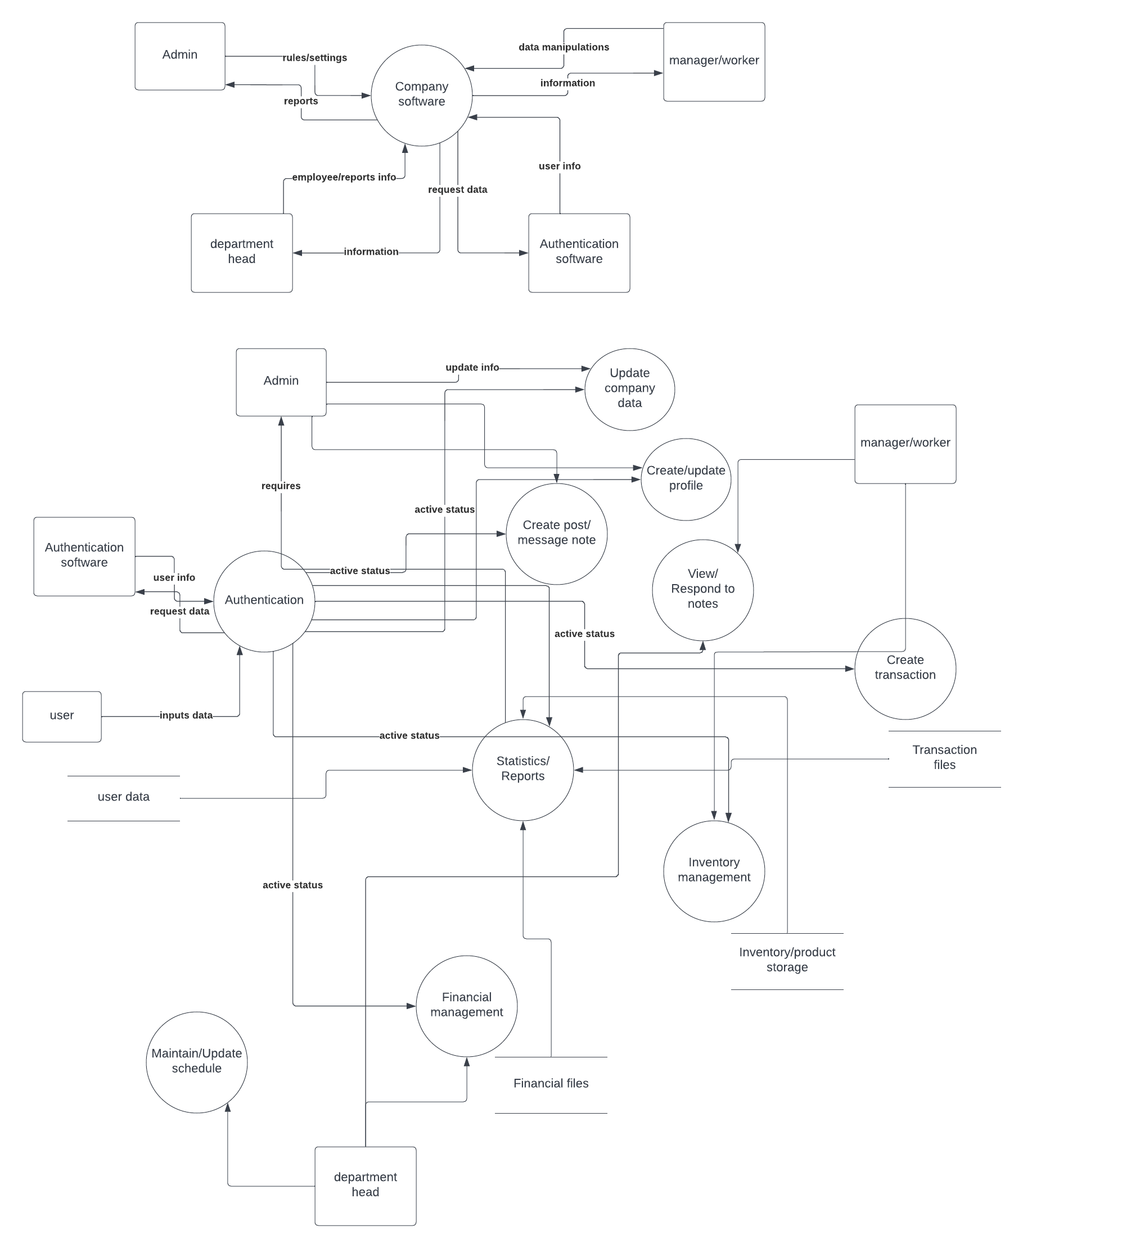

**Level 1**

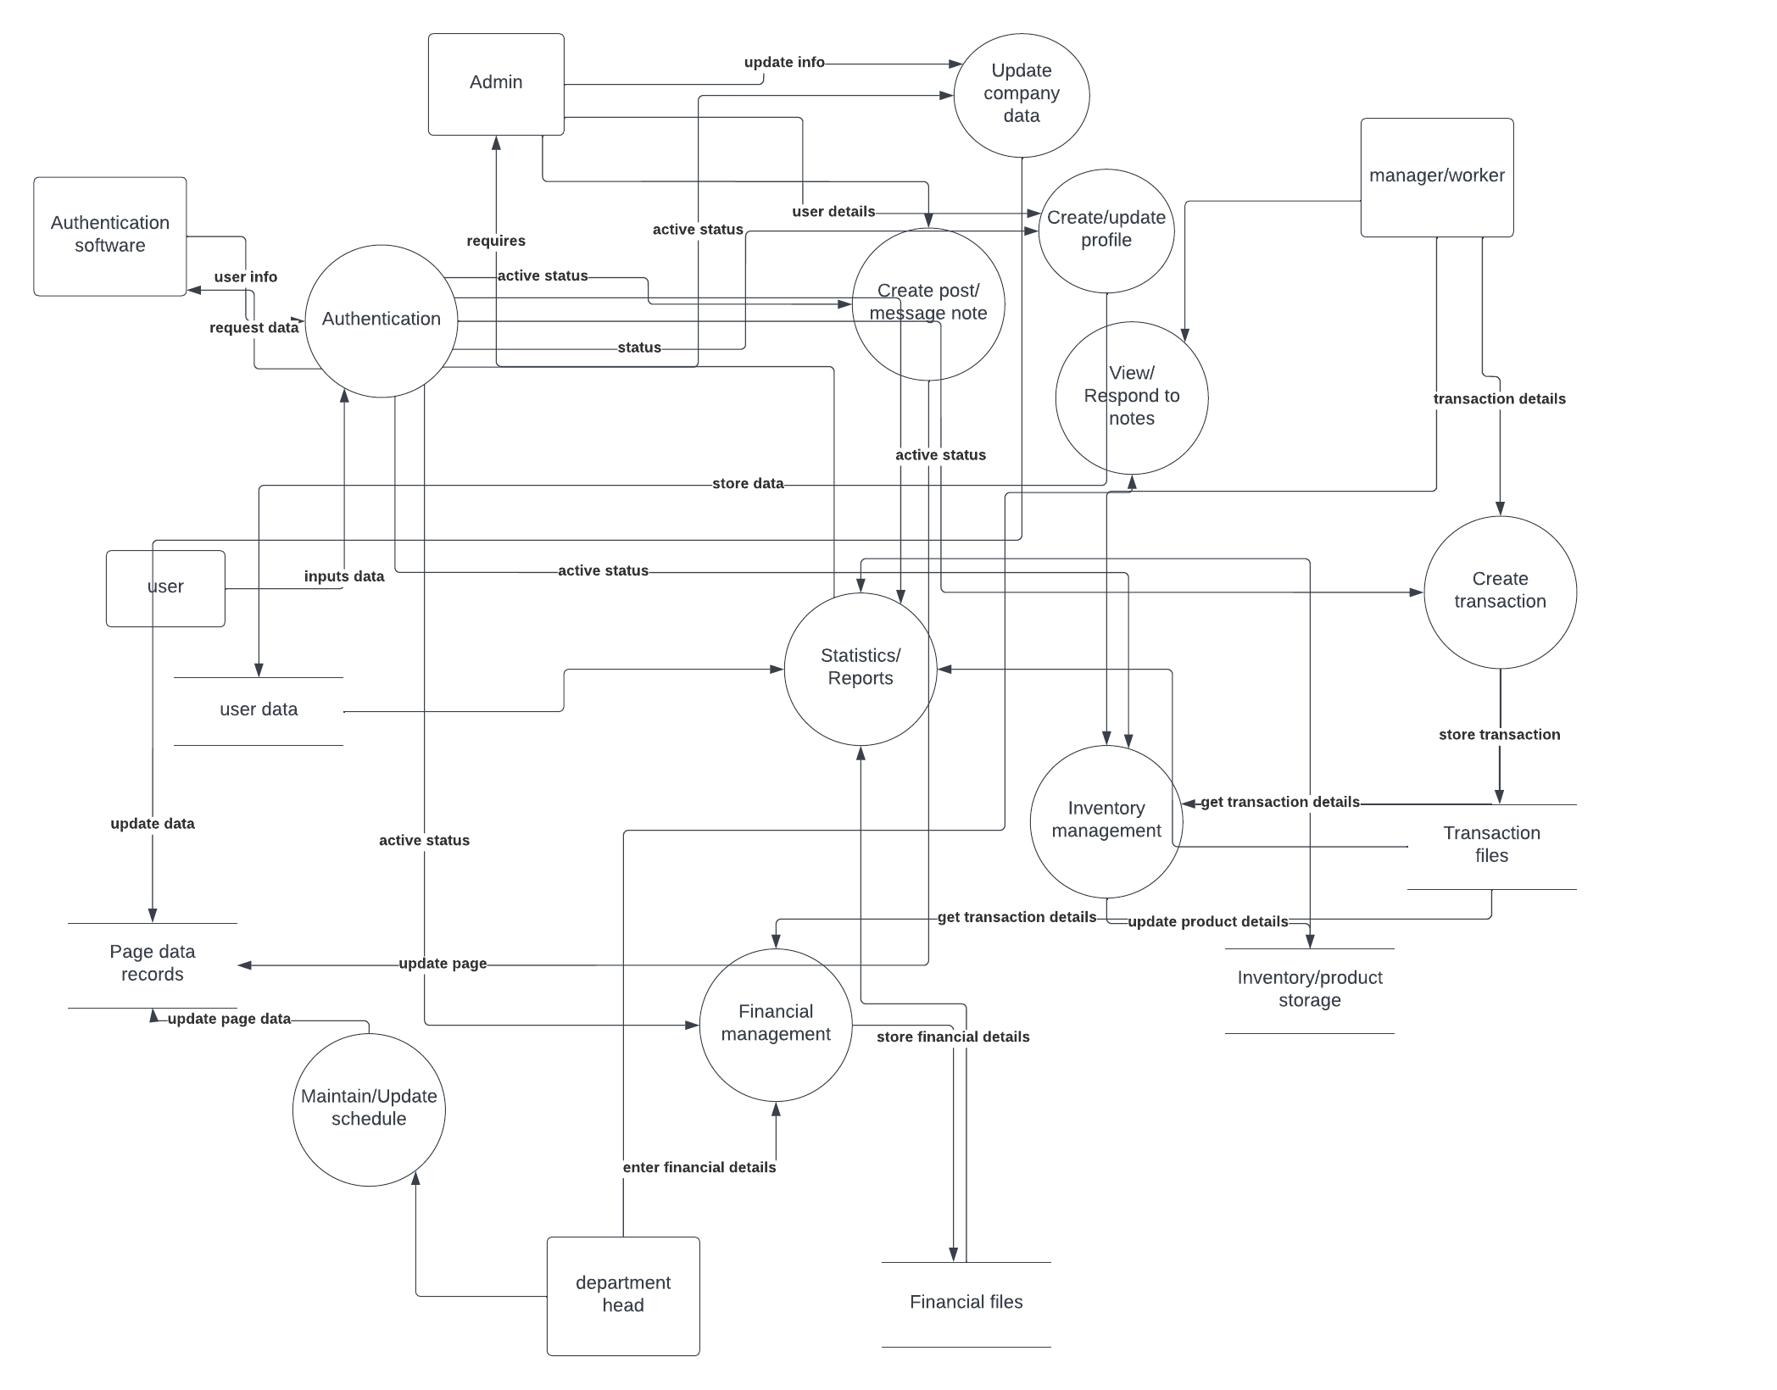

**Level 2**

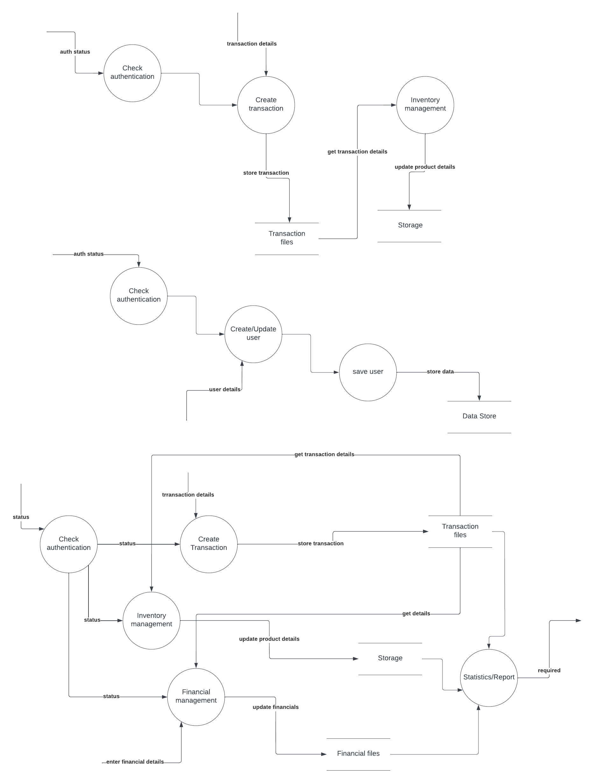

**4.5 ER Diagram**

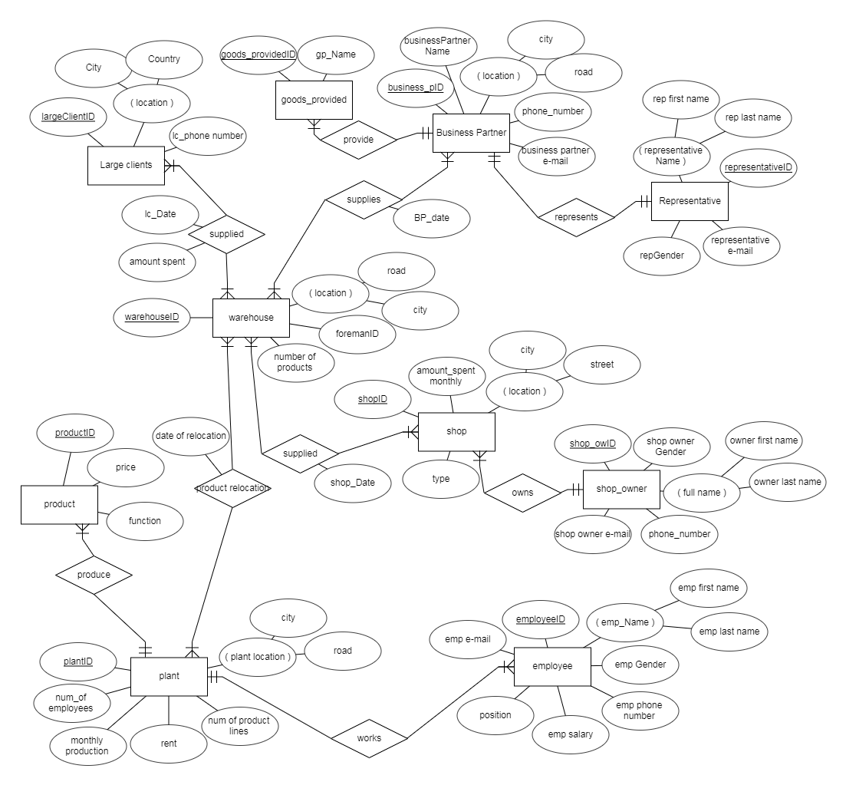

**4.6 BPMN**

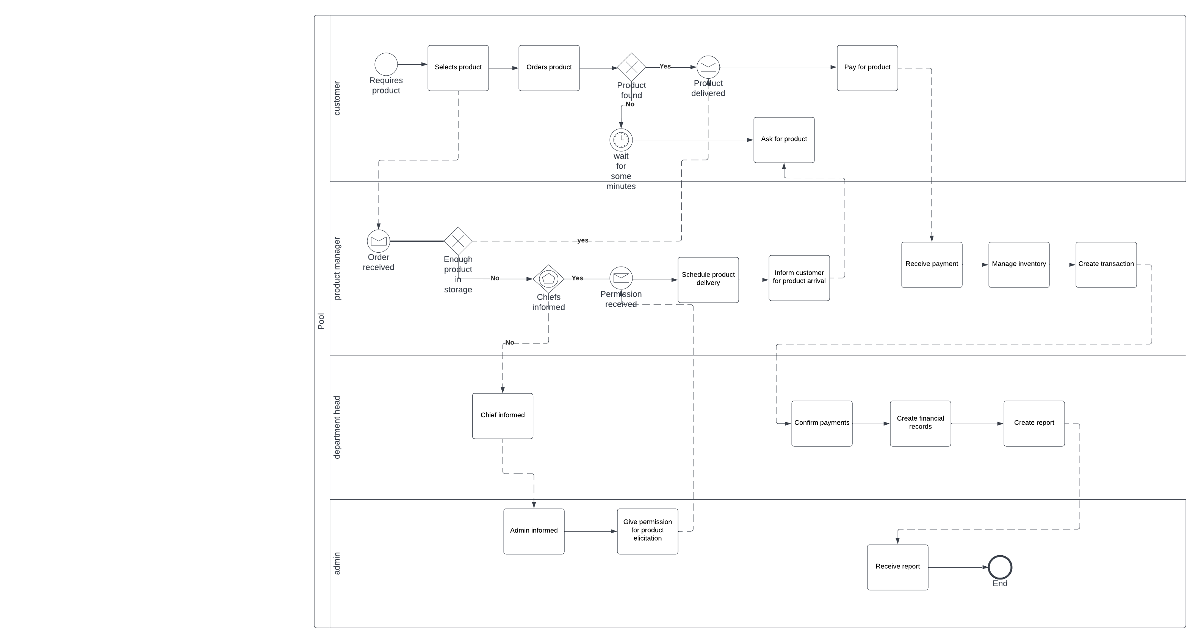

**4.7 Activity Diagrams**

**Log in (successful / unsuccessful)**

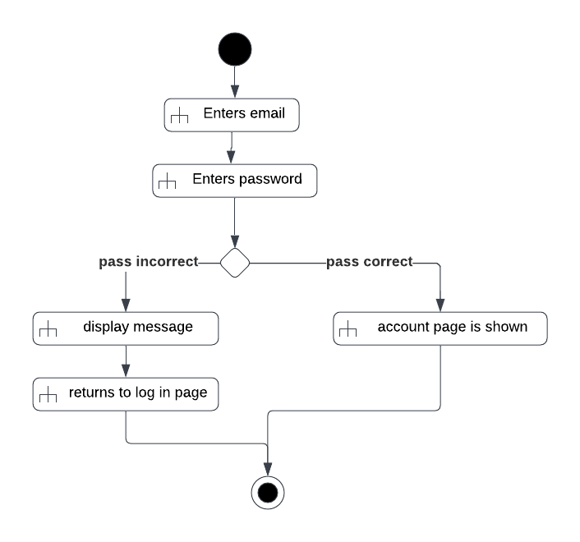

**ADMINISTRATOR**

**Creating Employee Accounts**

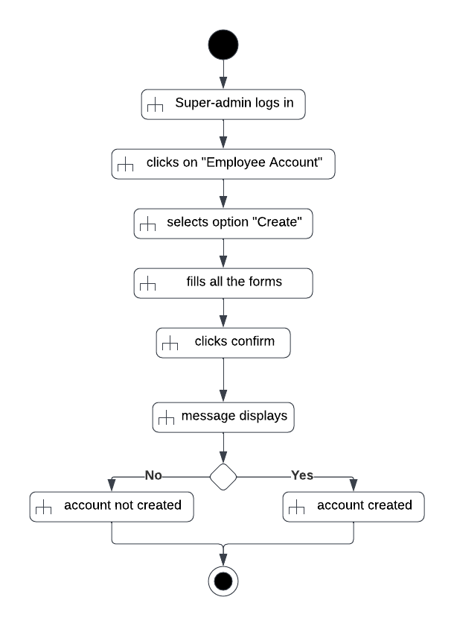

**Deleting Employee Accounts**

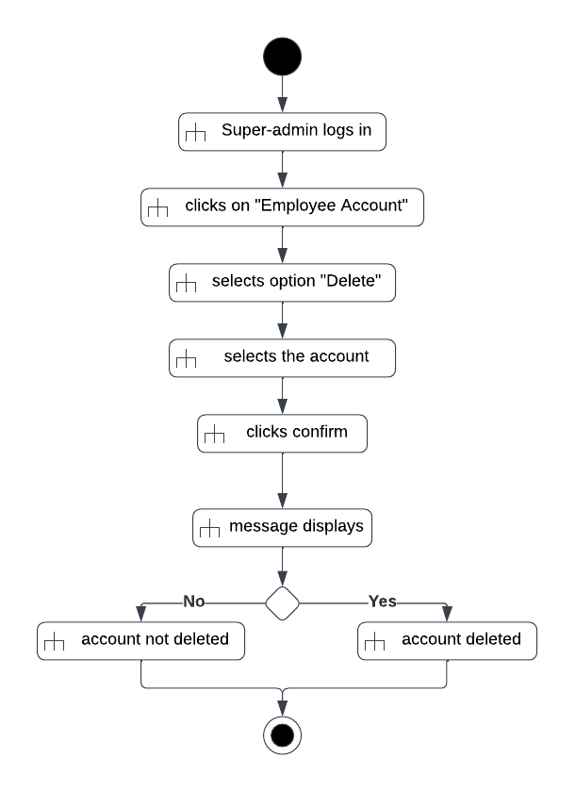

**Checks Payments**

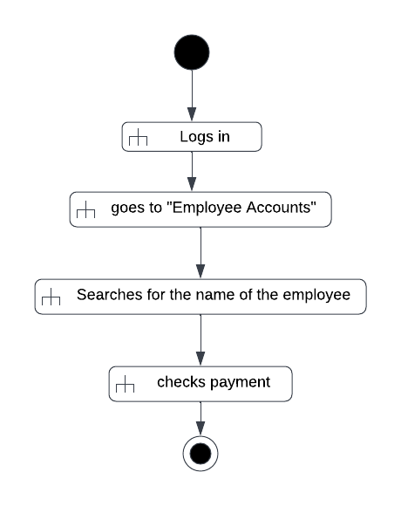

**Updates company location**

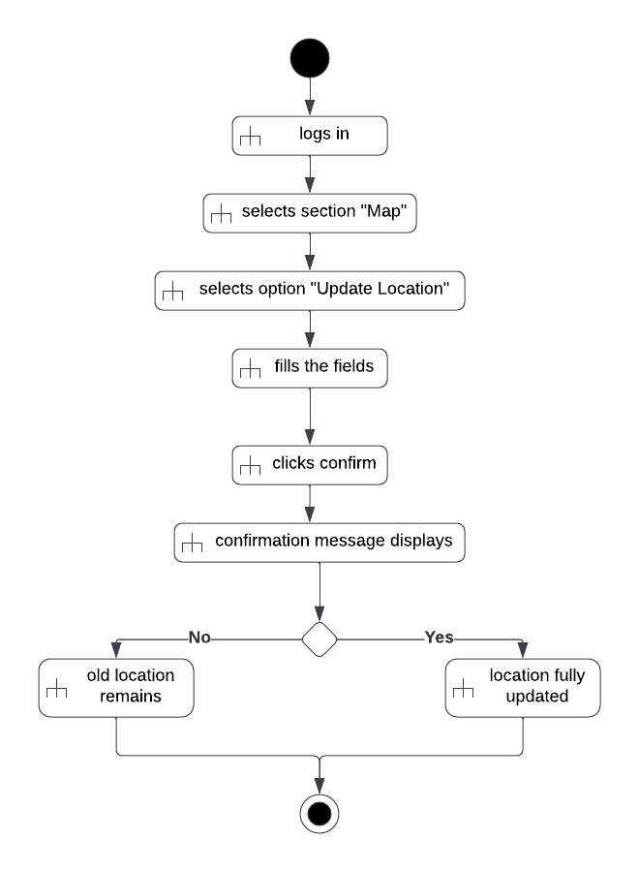

**Check deliveries**

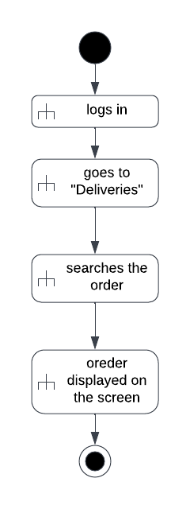

**Checks Inventory**

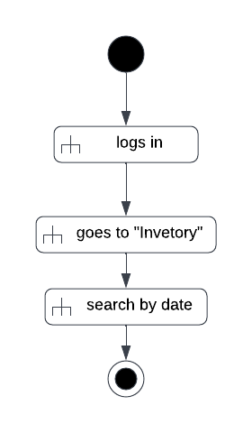

**Updates chat system**

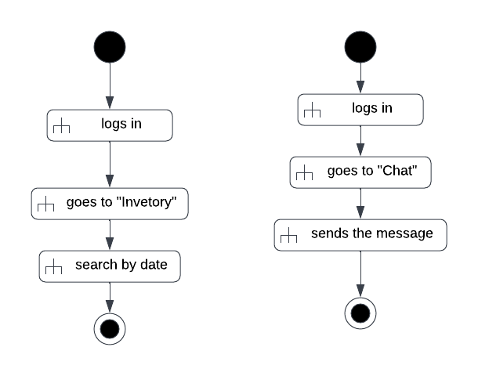

**Control Financial Records**

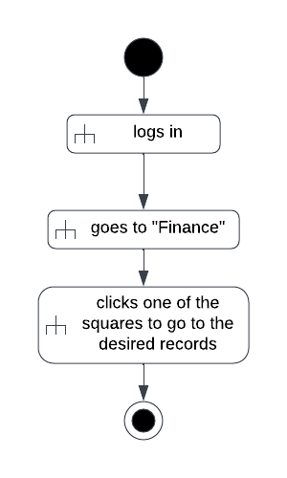

**Control Security cameras**

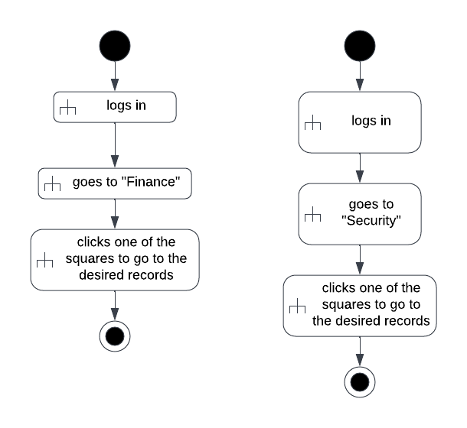

**Permission for sick leave**

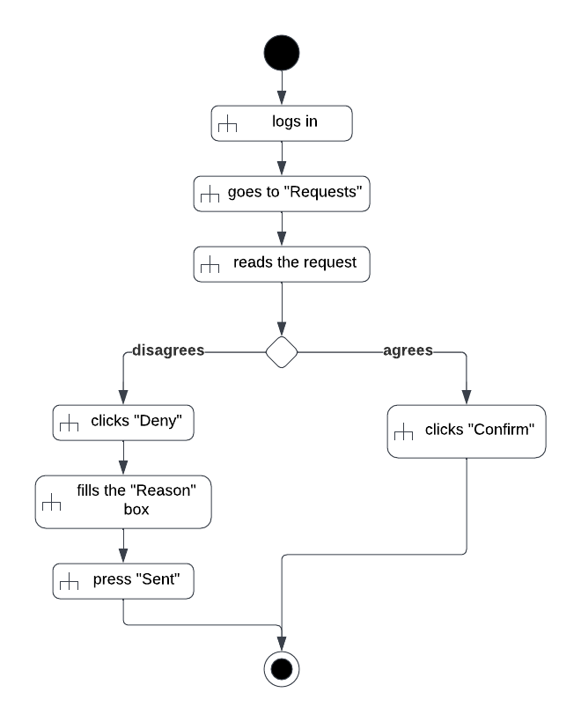

**MANAGERS**

**Transport Manager**



**Packing Manager**

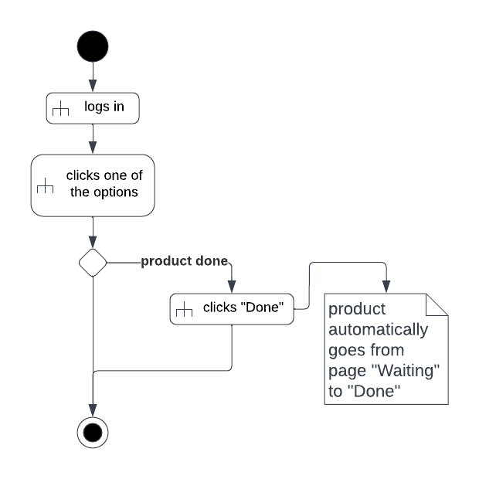

**Transaction Manager**



**Security Manager**

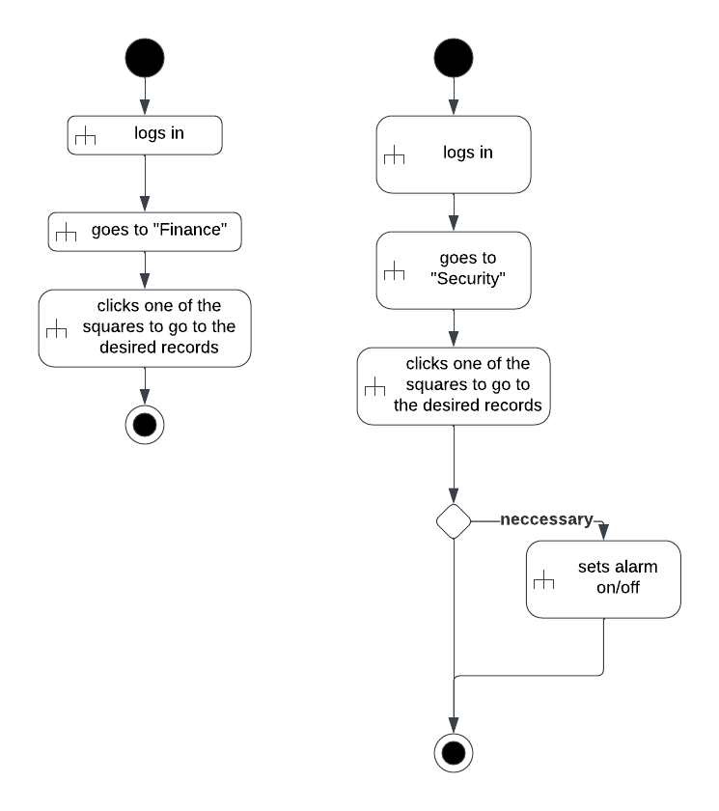

**DEPARTMENT HEADER**

**Fill daily Reports**

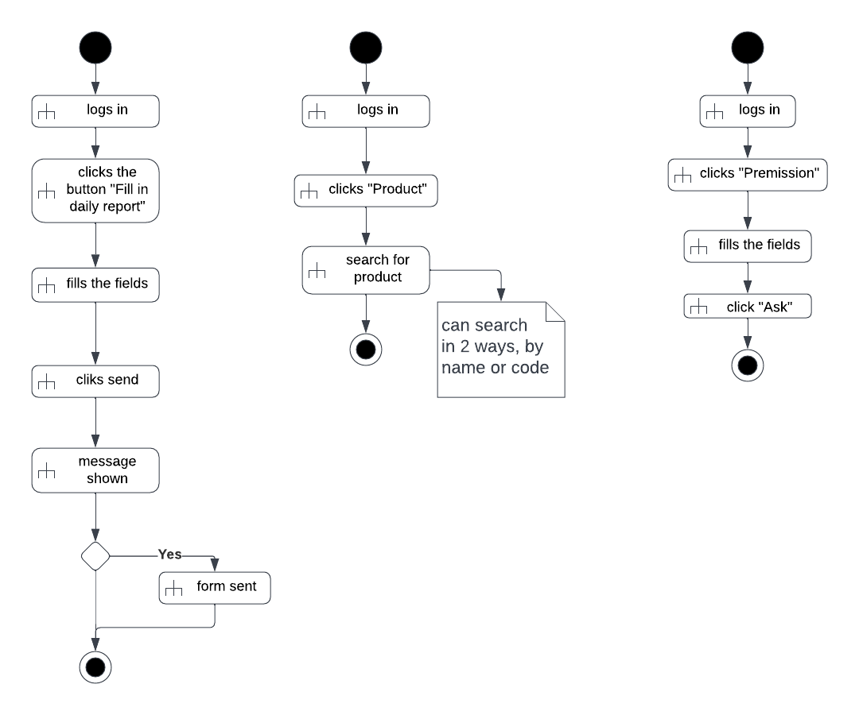

**Check monthly quantities**



**Check Deadline**



**Register working hours**

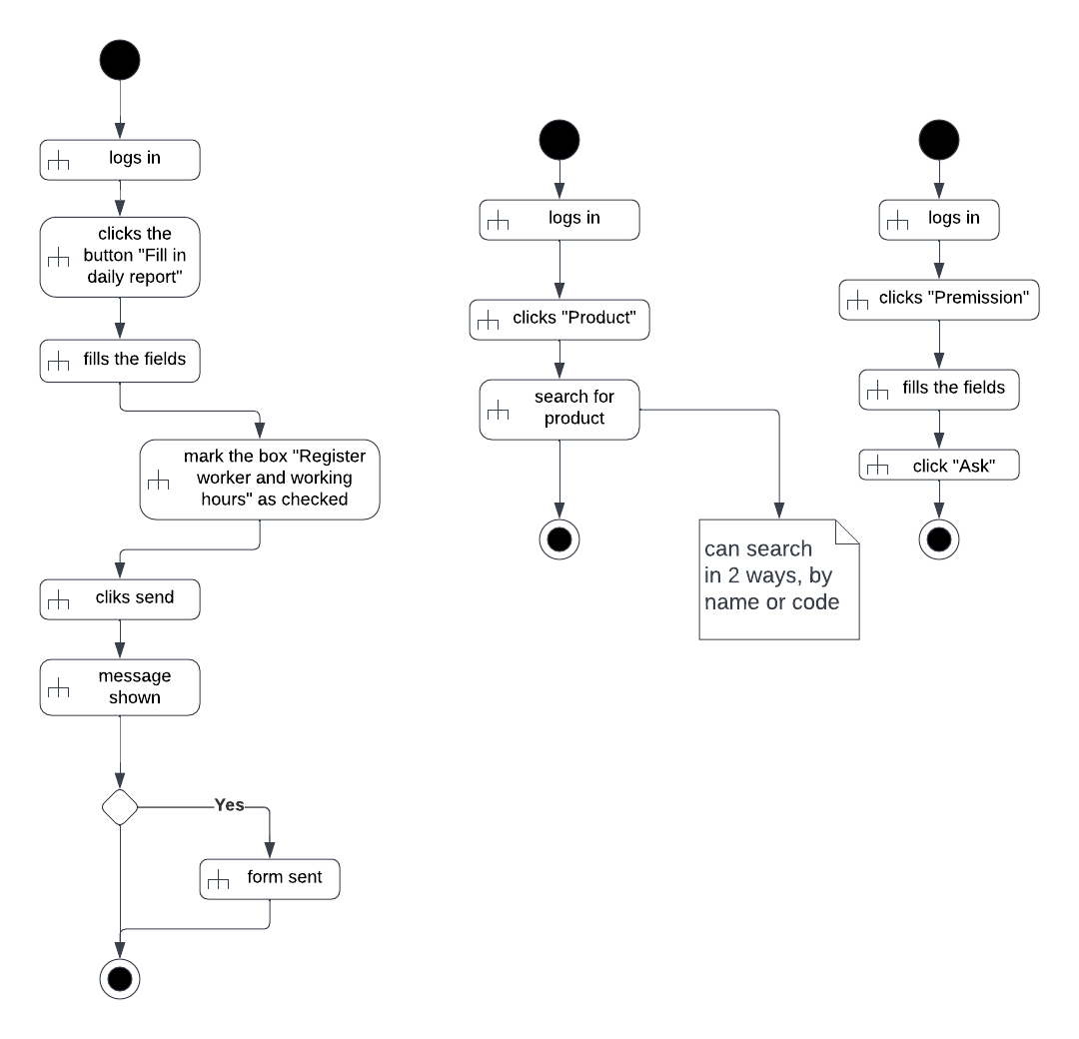

**Ask for permission**



**CLIENTS**

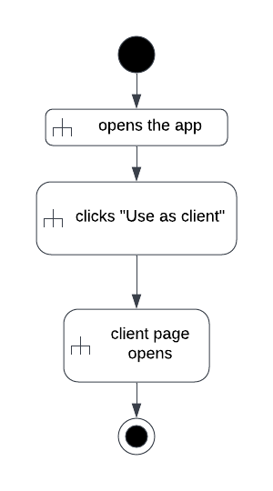

**4.8 State Diagrams**

**Map**

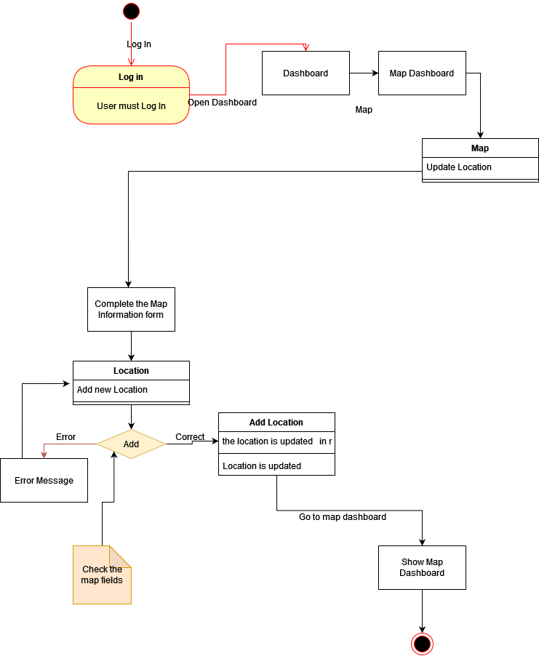

**Employee**

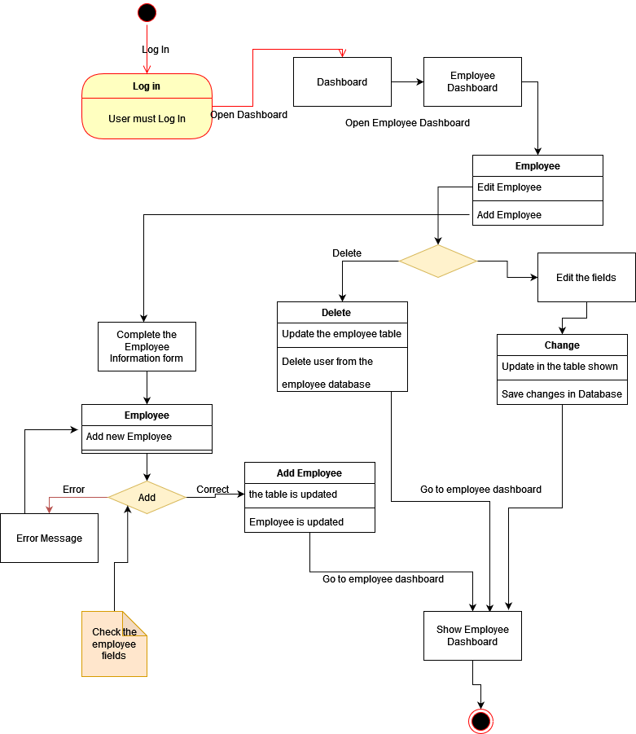

**Deliveries**

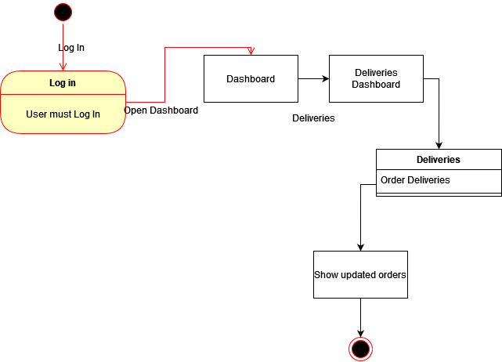

**4.9 Sequence Diagrams**

**Log in**

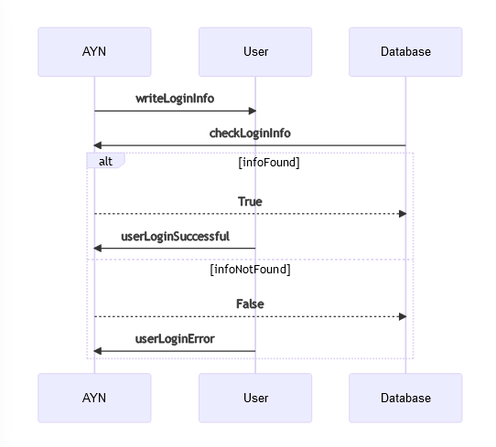

**Employees**

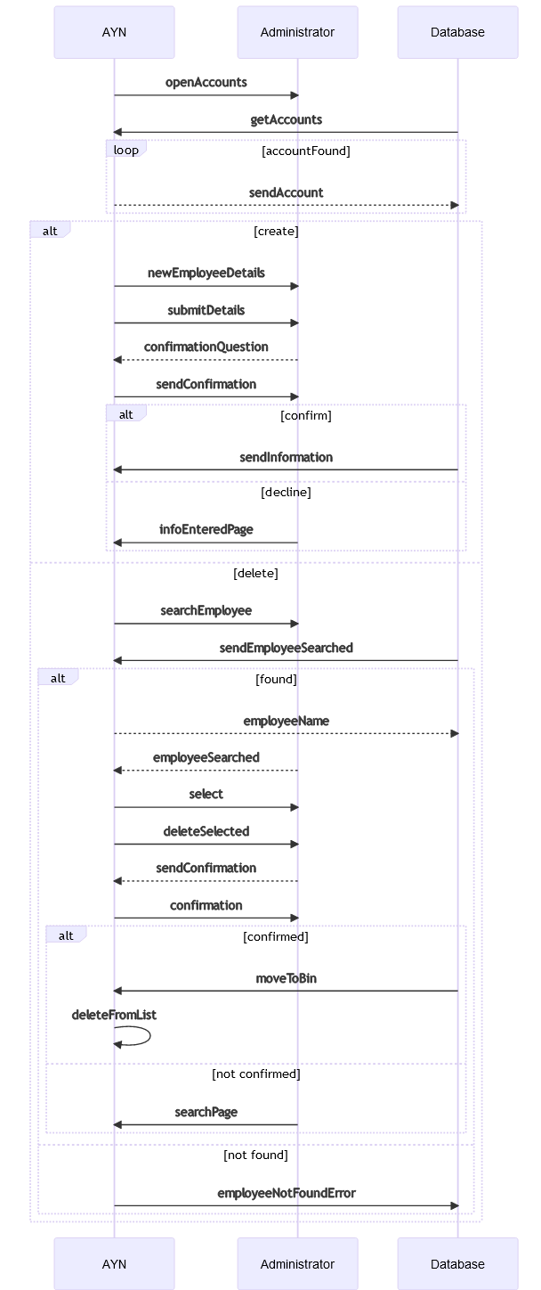

**Employee Wage**

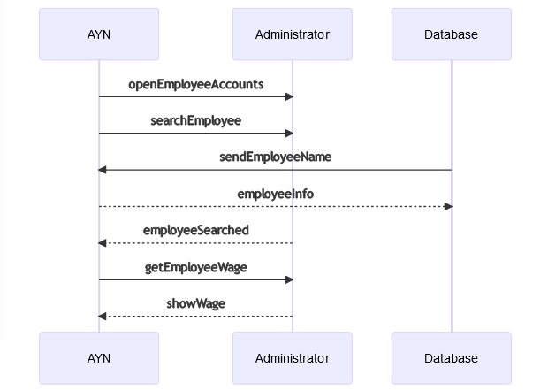

**Update Map**

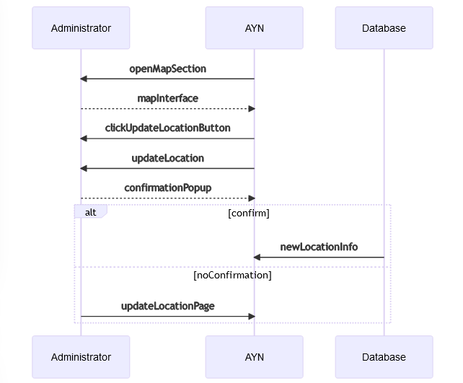

**Check Deliveries**

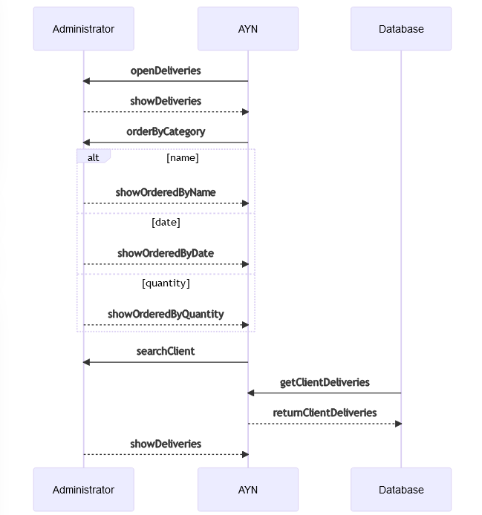

**Check Inventory**

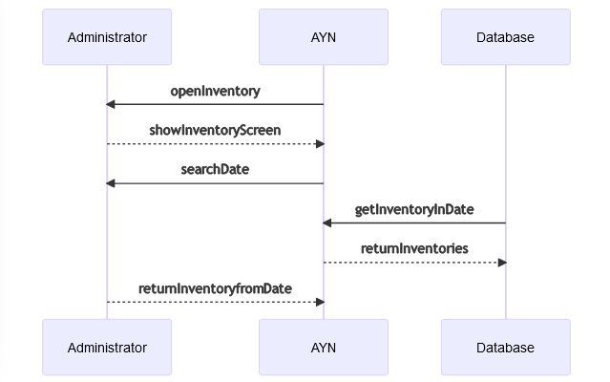

**Update Chat**

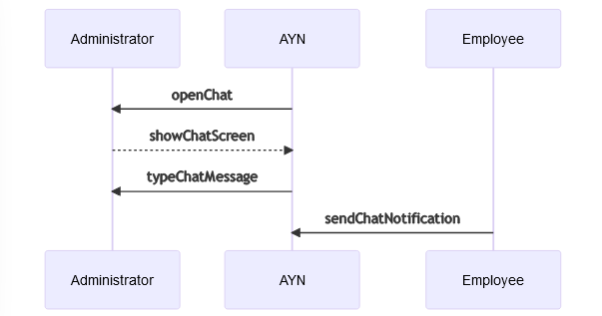

**Check Financial Records**

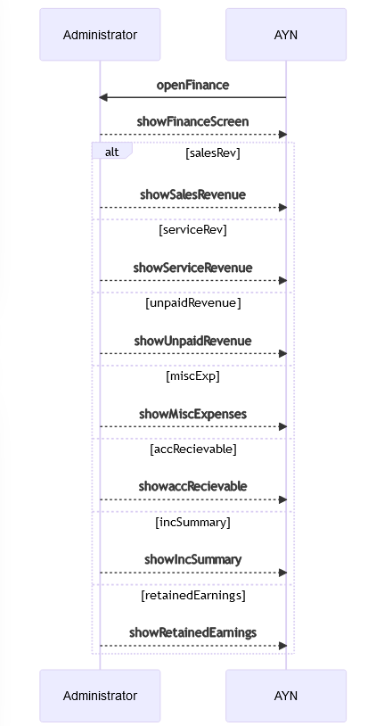

**Check Security Cameras**

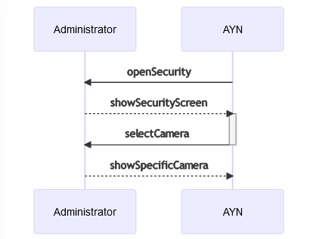

**Permission for sick leaves**

